**Requirement 1**

**Nomor 1 - db_melodi_indah**

* List Tabel

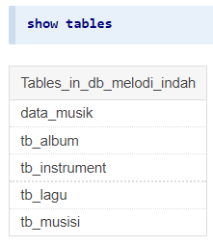

Terdapat 4 tabel dan 1 view yang tersimpan di database db_elodi_indah. 4 tabel dengan awalan tb adalah data yang diinsertkan, sedangkan data_musik adalah view tampilan dari data agar terstruktur.

* Data dari tb_instrument

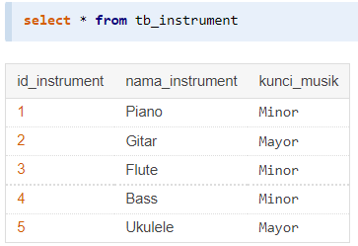

Tabel tb_instrument memiliki 3 kolom yaitu:

* id_instrument int (11) primary-key auto-increment
* nama_instrument varchar (50)
* kunci_musik enum (Mayor,Minor)
* Data dari tb_musisi

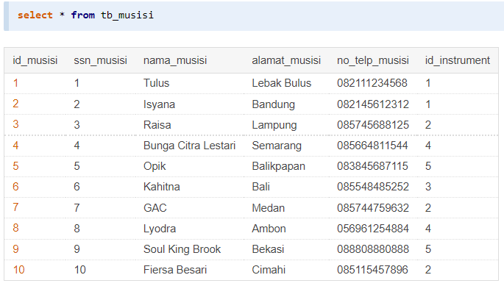

Tabel tb_musisi memiliki 6 kolom yaitu:

* id_musisi int (11) primary-key auto-increment
* ssn_musisi int (11) unique
* nama_musisi varchar (50)
* alamat_musisi text
* no_telp_musisi varchar (50)
* id_instrument foreign-key dari id_instrument tb_instument
* Data dari tb_album

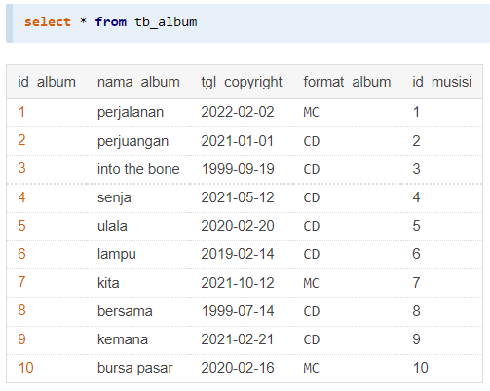

Tabel tb_album memiliki 5 kolom yaitu:

* id_album int (11) primary-key auto-increment
* nama_album varchar (50)
* tgl_copyright date
* format_album enum (CD, MC)
* id_musisi foreign-key dari id_musisi tb_musisi
* Data dari tb_lagu

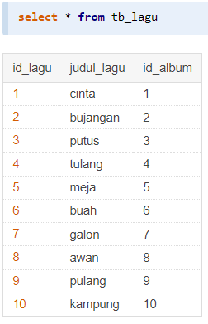

Tabel tb_alagu memiliki 3 kolom yaitu:

* id_lagu int (11) primary-key auto-increment
* judul_lagu varchar (50)
* id_album foreign=key dari id_album tb_album
* Data dari view_musik

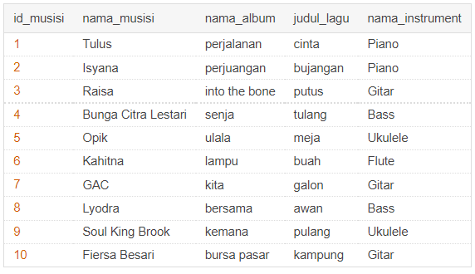

View_musik merupakan hasil join dari setiap table sebelumnya sehingga output dapat terstruktur dan dapat di presentasikan.

**Requirement 2**

**Nomor 2 – Database Schema from employee_sesi12**

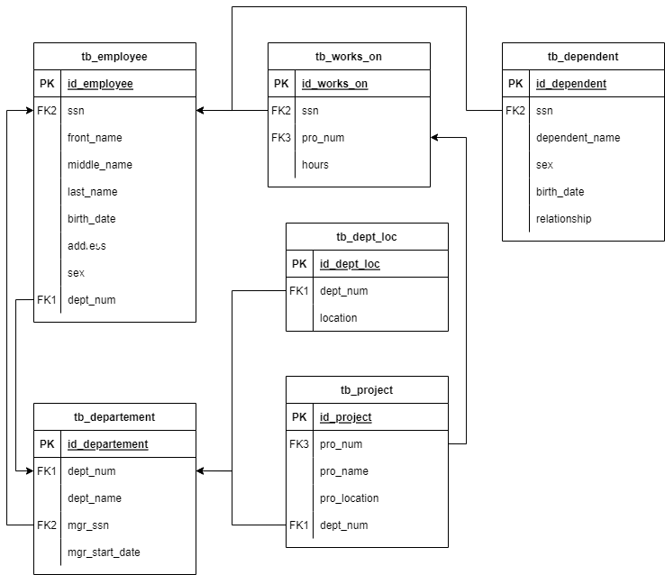

Dibuat sebuah schema untuk database employee_sesi12 yang berisi 6 tabel.

Terdapat 3 foreign-key yaitu :

* FK1, bersumber dari tb_departement.dept_num lalu menargetkan kepada tb_employee.dept_num, tb_project.dept_num dan tb_dept_loc.dept_num
* FK2, bersumber dari tb_employee.ssn lalu menargetkan kepada tb_departement.mgr_ssn, tb_works_on.ssn, dan tb_dependent.ssn
* FK3, bersumber dari tb_project.pro+num lalu menargetkan kepada tb_works_on.pro_num

**Nomor 3**

Terdapat perinitah-perintah untuk membuat query dari setiap keadaan yaitu:

1. Tampilkan dependent_name dan relationship dengan employee yang namanya diawali huruf R ?

[**create view**](https://mariadb.com/kb/en/library/create-view/) [poin_a](http://localhost/adminer/?server=localhost&username=root&db=employee_sesi12&table=poin_a) as  
[**select**](https://mariadb.com/kb/en/library/select/)  
 temp.first_name,  
 tdepen.dependent_name,  
 tdepen.relationship  
from  
 [tb_dependent](http://localhost/adminer/?server=localhost&username=root&db=employee_sesi12&table=tb_dependent) tdepen  
[**join**](https://mariadb.com/kb/en/library/join/)  
 [tb_employee](http://localhost/adminer/?server=localhost&username=root&db=employee_sesi12&table=tb_employee) temp on temp.ssn=tdepen.ssn  
where  
 temp.first_name [**like**](https://mariadb.com/kb/en/library/string-comparison-functions/#operator_like) 'r%'

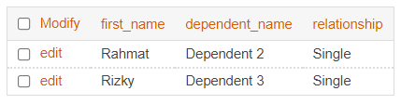

1. Banyaknya employee yang mengerjakan project PNum = 1 ?

[**create view**](https://mariadb.com/kb/en/library/create-view/) poin_b as  
[**select**](https://mariadb.com/kb/en/library/select/)  
 [**count**](https://mariadb.com/kb/en/library/group-by-functions/#function_count)(id_works_on) as "Jumlah orang yang mengerjakan Project 1"  
from  
 [tb_works_on](http://localhost/adminer/?server=localhost&username=root&db=employee_sesi12&table=tb_works_on)  
where  
 pro_num=1

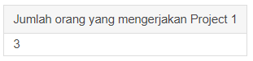

1. Banyaknya employee yang memiliki salary lebih dari 3500000

[**create view**](https://mariadb.com/kb/en/library/create-view/) [poin_c](http://localhost/adminer/?server=localhost&username=root&db=employee_sesi12&table=poin_c) as  
[**select**](https://mariadb.com/kb/en/library/select/)  
 "Jumlah salary > 3500000" as field,  
 [**count**](https://mariadb.com/kb/en/library/group-by-functions/#function_count)(temp.salary) as total  
from  
 [tb_employee](http://localhost/adminer/?server=localhost&username=root&db=employee_sesi12&table=tb_employee) temp  
where  
 salary>3500000

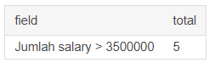

1. Banyaknya project yang dikerjakan DNum =2 ?

[**create view**](https://mariadb.com/kb/en/library/create-view/) [poin_d](http://localhost/adminer/?server=localhost&username=root&db=employee_sesi12&table=poin_d) as  
[**select**](https://mariadb.com/kb/en/library/select/)  
 [**count**](https://mariadb.com/kb/en/library/group-by-functions/#function_count)(pro_num) as "Banyak Project yang Dikerjakan Dept 2"  
from  
 [tb_project](http://localhost/adminer/?server=localhost&username=root&db=employee_sesi12&table=tb_project)  
where  
 dept_num = 2

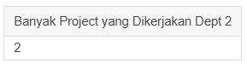

1. Hitung total dan rata-rata salary dari setiap departemen ?

[**create view**](https://mariadb.com/kb/en/library/create-view/) [poin_e](http://localhost/adminer/?server=localhost&username=root&db=employee_sesi12&table=poin_e) as  
[**select**](https://mariadb.com/kb/en/library/select/)  
 tdept.dept_name as nama_departemen,  
 [**avg**](https://mariadb.com/kb/en/library/group-by-functions/#function_avg) (temp.salary) as rata_rata_gaji  
from  
 [tb_employee](http://localhost/adminer/?server=localhost&username=root&db=employee_sesi12&table=tb_employee) temp  
[**join**](https://mariadb.com/kb/en/library/join/)  
 [tb_departement](http://localhost/adminer/?server=localhost&username=root&db=employee_sesi12&table=tb_departement) tdept on tdept.dept_num=temp.dept_num  
group by  
 tdept.dept_num

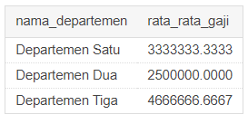

1. Banyaknya employee dari setiap department dan urutkan berdasarkan employee terbanyak ?

[**create view**](https://mariadb.com/kb/en/library/create-view/) [poin_f](http://localhost/adminer/?server=localhost&username=root&db=employee_sesi12&table=poin_f) as  
[**select**](https://mariadb.com/kb/en/library/select/)  
 tdept.dept_name as nama_departement,  
 [**count**](https://mariadb.com/kb/en/library/group-by-functions/#function_count)(temp.ssn) as jumlah_karyawan  
from  
 [tb_employee](http://localhost/adminer/?server=localhost&username=root&db=employee_sesi12&table=tb_employee) temp  
[**join**](https://mariadb.com/kb/en/library/join/)  
 [tb_departement](http://localhost/adminer/?server=localhost&username=root&db=employee_sesi12&table=tb_departement) tdept on tdept.dept_num=temp.dept_num  
group by  
 tdept.dept_num

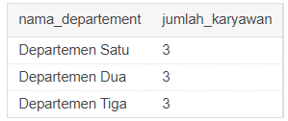

1. Total hours perweek dari semua employee untuk setiap project ?

[**create view**](https://mariadb.com/kb/en/library/create-view/) [poin_g](http://localhost/adminer/?server=localhost&username=root&db=employee_sesi12&table=poin_g) as  
[**select**](https://mariadb.com/kb/en/library/select/)  
 tpro.pro_name as nama_project,  
 [**sum**](https://mariadb.com/kb/en/library/group-by-functions/#function_sum)(tw.hours) as total_jam  
from  
 [tb_works_on](http://localhost/adminer/?server=localhost&username=root&db=employee_sesi12&table=tb_works_on) tw  
[**join**](https://mariadb.com/kb/en/library/join/)  
 [tb_project](http://localhost/adminer/?server=localhost&username=root&db=employee_sesi12&table=tb_project) tpro on tpro.pro_num=tw.pro_num  
group by  
 tw.pro_num

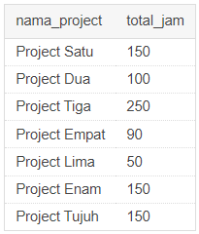

1. Employee yang memiliki total hours perweek lebih besar dari 140 hours dan urutkan berdasarkan jumlah jam kerja terbanyak?

[**create view**](https://mariadb.com/kb/en/library/create-view/) poin_h as  
[**select**](https://mariadb.com/kb/en/library/select/)  
 temp.first_name as nama,  
 [**sum**](https://mariadb.com/kb/en/library/group-by-functions/#function_sum)(tw.hours) as total_jam  
from  
 [tb_employee](http://localhost/adminer/?server=localhost&username=root&db=employee_sesi12&table=tb_employee) temp  
[**join**](https://mariadb.com/kb/en/library/join/)  
 [tb_works_on](http://localhost/adminer/?server=localhost&username=root&db=employee_sesi12&table=tb_works_on) tw on temp.ssn=tw.ssn  
group by  
 tw.ssn  
having [**sum**](https://mariadb.com/kb/en/library/group-by-functions/#function_sum)(tw.hours)>140  
order by  
 [**sum**](https://mariadb.com/kb/en/library/group-by-functions/#function_sum)(tw.hours) desc

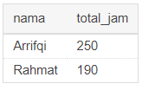

1. Kelompokkan bonus employee berdasarkan jumlah jam kerjanya ? (Jika >= 200 hours, maka bonus = 50%; Jika >= 150 hours, maka bonus = 25%, Selainnya bonus = 10%)

[**create view**](https://mariadb.com/kb/en/library/create-view/) poin_i as  
[**select**](https://mariadb.com/kb/en/library/select/)  
 temp.first_name as nama,  
 [**sum**](https://mariadb.com/kb/en/library/group-by-functions/#function_sum)(tw.hours) as total_jam,  
 [**case**](https://mariadb.com/kb/en/library/control-flow-functions/#operator_case)   
 when [**sum**](https://mariadb.com/kb/en/library/group-by-functions/#function_sum)(tw.hours) > 200 then '50%'  
 when [**sum**](https://mariadb.com/kb/en/library/group-by-functions/#function_sum)(tw.hours) > 150 then '25%'  
 else '10%'  
 [**end**](https://mariadb.com/kb/en/library/begin-end/) as bonus  
from  
 [tb_employee](http://localhost/adminer/?server=localhost&username=root&db=employee_sesi12&table=tb_employee) temp  
[**join**](https://mariadb.com/kb/en/library/join/)  
 [tb_works_on](http://localhost/adminer/?server=localhost&username=root&db=employee_sesi12&table=tb_works_on) tw on temp.ssn=tw.ssn  
group by  
 tw.ssn  
order by  
 [**sum**](https://mariadb.com/kb/en/library/group-by-functions/#function_sum)(tw.hours) desc

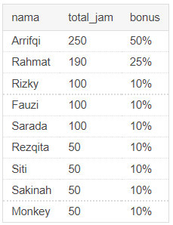

1. Banyaknya project yang dikerjakan tiap employee dan urutkan dari yang terbanyak ?

[**create view**](https://mariadb.com/kb/en/library/create-view/) poin_j as  
[**select**](https://mariadb.com/kb/en/library/select/)  
 temp.first_name as nama,  
 [**count**](https://mariadb.com/kb/en/library/group-by-functions/#function_count)(tw.pro_num) as jumlah_project  
from  
 [tb_employee](http://localhost/adminer/?server=localhost&username=root&db=employee_sesi12&table=tb_employee) temp  
[**join**](https://mariadb.com/kb/en/library/join/)  
 [tb_works_on](http://localhost/adminer/?server=localhost&username=root&db=employee_sesi12&table=tb_works_on) tw on temp.ssn=tw.ssn  
group by  
 temp.ssn  
order by  
 [**sum**](https://mariadb.com/kb/en/library/group-by-functions/#function_sum)(tw.hours) desc

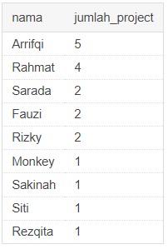

1. Employee yang bekerja pada 4 project / lebih?

[**create view**](https://mariadb.com/kb/en/library/create-view/) poin_k as  
[**select**](https://mariadb.com/kb/en/library/select/)  
 temp.first_name as nama,  
 [**count**](https://mariadb.com/kb/en/library/group-by-functions/#function_count)(tw.pro_num) as jumlah_project  
from  
 [tb_employee](http://localhost/adminer/?server=localhost&username=root&db=employee_sesi12&table=tb_employee) temp  
[**join**](https://mariadb.com/kb/en/library/join/)  
 [tb_works_on](http://localhost/adminer/?server=localhost&username=root&db=employee_sesi12&table=tb_works_on) tw on temp.ssn=tw.ssn  
group by  
 temp.ssn  
having [**count**](https://mariadb.com/kb/en/library/group-by-functions/#function_count)(tw.pro_num)>=4  
order by  
 [**sum**](https://mariadb.com/kb/en/library/group-by-functions/#function_sum)(tw.hours) desc

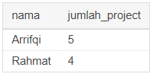

1. Employee yang memiliki rata-rata hours perweek = 50 jam dan bekerja pada >=2 project ?

[**create view**](https://mariadb.com/kb/en/library/create-view/) poin_l as  
[**select**](https://mariadb.com/kb/en/library/select/)  
 temp.first_name as nama,  
 [**avg**](https://mariadb.com/kb/en/library/group-by-functions/#function_avg)(tw.hours) as rata_total_jam,  
 [**count**](https://mariadb.com/kb/en/library/group-by-functions/#function_count)(tw.pro_num) as total_project  
from  
 [tb_employee](http://localhost/adminer/?server=localhost&username=root&db=employee_sesi12&table=tb_employee) temp  
[**join**](https://mariadb.com/kb/en/library/join/)  
 [tb_works_on](http://localhost/adminer/?server=localhost&username=root&db=employee_sesi12&table=tb_works_on) tw on temp.ssn=tw.ssn  
group by  
 tw.ssn  
having [**avg**](https://mariadb.com/kb/en/library/group-by-functions/#function_avg)(tw.hours)>=50 [**and**](https://mariadb.com/kb/en/library/logical-operators/#operator_and) [**count**](https://mariadb.com/kb/en/library/group-by-functions/#function_count)(tw.pro_num)>=2  
order by  
 [**sum**](https://mariadb.com/kb/en/library/group-by-functions/#function_sum)(tw.hours) desc

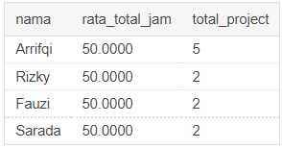

1. Banyaknya Dependent berdasarkan relationship dengan employee ?

[**create view**](https://mariadb.com/kb/en/library/create-view/) [poin_m](http://localhost/adminer/?server=localhost&username=root&db=employee_sesi12&table=poin_m) as  
[**select**](https://mariadb.com/kb/en/library/select/)  
 td.relationship as relation,  
 [**count**](https://mariadb.com/kb/en/library/group-by-functions/#function_count)(td.relationship) as total_dependent  
from  
 [tb_employee](http://localhost/adminer/?server=localhost&username=root&db=employee_sesi12&table=tb_employee) temp  
[**join**](https://mariadb.com/kb/en/library/join/)  
 [tb_dependent](http://localhost/adminer/?server=localhost&username=root&db=employee_sesi12&table=tb_dependent) td on temp.ssn=td.ssn  
group by  
 td.relationship

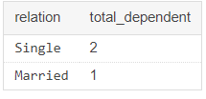

1. Berapa lama Manager tiap Department sudah menjabat ?

[**create view**](https://mariadb.com/kb/en/library/create-view/) [poin_n](http://localhost/adminer/?server=localhost&username=root&db=employee_sesi12&table=poin_n) as  
[**select**](https://mariadb.com/kb/en/library/select/)  
 temp.first_name as name,  
 td.dept_name as departement,  
 mgr_start_date as tgl_mulai,  
 [**timestampdiff**](https://mariadb.com/kb/en/library/date-and-time-functions/#function_timestampdiff)(month, mgr_start_date, [**curdate**](https://mariadb.com/kb/en/library/date-and-time-functions/#function_curdate)()) as lama_menjabat_bulan  
from  
 [tb_employee](http://localhost/adminer/?server=localhost&username=root&db=employee_sesi12&table=tb_employee) temp  
[**join**](https://mariadb.com/kb/en/library/join/)  
 [tb_departement](http://localhost/adminer/?server=localhost&username=root&db=employee_sesi12&table=tb_departement) td on temp.ssn=td.mgr_ssn  
order by   
[**timestampdiff**](https://mariadb.com/kb/en/library/date-and-time-functions/#function_timestampdiff)(month, mgr_start_date, [**curdate**](https://mariadb.com/kb/en/library/date-and-time-functions/#function_curdate)()) desc

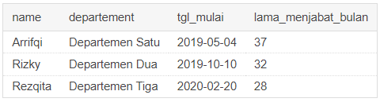

1. Lokasi project yang menjadi tempat lebih dari satu department?

[**create view**](https://mariadb.com/kb/en/library/create-view/) poin_o as  
[**select**](https://mariadb.com/kb/en/library/select/)  
 tp.pro_location,  
 [**count**](https://mariadb.com/kb/en/library/group-by-functions/#function_count)(tp.pro_location) as berapa_kali_menjadi_tempat_project  
from  
 [tb_project](http://localhost/adminer/?server=localhost&username=root&db=employee_sesi12&table=tb_project) tp  
group by  
 tp.pro_location  
order by  
 [**count**](https://mariadb.com/kb/en/library/group-by-functions/#function_count)(tp.pro_location) desc

